Application of WEAP in the Analysis of Water Infrastructure as Domestic Water Supply Management Approach in Jamshoro Sindh, Pakistan

Nadia Jannath Nishu  College of Civil and Environmental Engineering  University of Utah, Salt Lake City, Utah | Ahmed Rafique  College of Civil and Environmental Engineering  University of Utah, Salt Lake City, Utah | Rakhshinda Bano  U.S Pakistan Center for Advanced Studies in Water, MUET, Jamshoro, Pakistan

Abstract
Rapid urban growth, climate change and the resulting change in water availability are stressing the urban supply system day by day. Sustainable water supply management requires the integration of all the needs and analysis of maximum possible management alternatives. The present research demonstrates the use of WEAP as an integrated modelling tool to identify the optimal water supply management strategies in Jamshoro, Pakistan under different future demand scenarios. Water infrastructure alternative has been analyzed in terms of the system performance metrics i.e. reliability, resiliency and vulnerability followed by cost-benefit analysis. With a population of 20,000 residents, Jamshoro city presents a myriad of domestic water supply management issues. Surface water which is the single water source available to the residents; comes from Kotri Barrage, the last diversion infrastructure on the Indus River System. Lacking a proper supply system alternative, the city has no water supply every year for a period of 30 days (during the maintenance of the diversion canals which supplies water to the city). Water infrastructure can be an optimal supply management strategy which would help store excess water supply during wet period and increase the availability during the dry period.
It would help the city residents save the huge proportions of their monthly income, they spend to meet the water needs.
Keywords: WEAP, Reliability, Resiliency, Vulnerability, cost-benefit ratio, supply management

Introduction
Indus River basin faces a multitude of water management challenges. Population growth, industrialization and inefficient water management are some of the major factors aggravated by climate change (Laghari et al., 2012; Memon et al., 2011). Water availability has decreased over time and it is anticipated that the condition will get worse in future (Archer, 2010). This situation compels us to explore water management options including both structural and nonstructural solutions to proceed for a sustainable water resource system. Cost effective infrastructural solutions have always been preferred to cope with the external pressures. These solutions have been applied to one of the cities in the Indus River Basin which is highly prone to poor water management and supply issues.
Jamshoro is a small city of 20,000 residents, located in lower Indus River Basin near Kotri Barrage. The population of this city, for domestic water supply, is highly dependent on Kalri Baghar (KB) Feeder canal which originates from a diversion on upstream of Kotri Barrage. The residents face multiple domestic water problems ranging from quantity to quality and poor management of the water. The water is available for few hours in the day and not sufficient to meet the demand at household level. Moreover, the water available is not potable and the citizens need to buy filtered water from the private companies, thus paying huge amount of money to meet the very basic needs. The city also has a zero supply from Kotri barrage from December 25- Jan 25 for the maintenance of KB Feeder and the citizen don’t have any other water supply for domestic use but groundwater which is of very low quality.
Additional supply (storage tank) is proposed to fulfill the consumer’s daily need and especially to supply demand for 30 days (when they have no water) during the maintenance period of KB Feeder canal. A storage tank is chosen as preferred solution over reservoir, as this site is highly infeasible for a reservoir. The tank will be filled on regular basis by installing more pumping capacity. As pumps require huge amount of operational cost, therefore, the energy requirement for the water supply is recommended to be fulfilled using either solar or wind energy as the area has a high potential for both sources of renewable energy (Sheikh, 2010).

Methods

WEAP Modelling
The schematics for the WEAP model was developed (Annexure 1), limiting the extent of model from Sukkur Barrage to the Demand Sites located downstream of Kotri Barrage. Sukkur Barrage inflow data was incorporated in the model and inflow requirements at Kotri Barrage were identified. Moreover, arbitrary sites were incorporated downstream of Sukkur Barrage, which divert the water from Sukkur Barrage to have required amount of flow upstream of Kotri Barrage. Demand values for Kotri domestic, industrial, and agriculture sectors were obtained from Condappa et al. (2009) and WAPDA. Further steps included development of management alternative scenarios through incorporation of storage tanks of three different storages and pumping capacity. Water system reliability, resiliency and vulnerability were calculated for both baseline scenario (without additional supply) and management alternative scenario (with additional supply) (Annexure 2).

System Performance

Water System Reliability
To assess the effectiveness of additional supply, as water management strategy, water system reliability was measured for reference scenario as well as under multiple supply options with varying storage and pumping capacity. Reliability was assessed in terms of the demands met with and without additional supply over the period i.e. 2006 - 2016.

Water System Resiliency and Vulnerability
Water system resiliency and vulnerability were assessed adopting the definitions of water system performance metrics by Hashimoto et al. (1982). Resiliency was measured as probability of system bouncing back from failure (inability to meet the water demands) while vulnerability was measured as a product of percent of water supply deficit and its associated probability.

Cost Benefit Analysis (CBA)
Cost benefit analysis was conducted to find out the economic feasibility of the additional supply. Calculations for costs included total capital and operational cost while the benefits were based on the cost avoided by the consumers in the presence of the additional supply.

RESULTS AND DISCUSSION

Calibration
To check the quality of inflow data used in model at upstream of Kotri Barrage, the model was calibrated by comparing the WEAP results and observed data collected from WAPDA. Figure 1: Calibration for simulated and observed values illustrates the comparison of the values. The values in 2010 show a greater difference in the observed and simulated values because the observed values for the year were missing and replaced with the average monthly values of previous years while modelling.
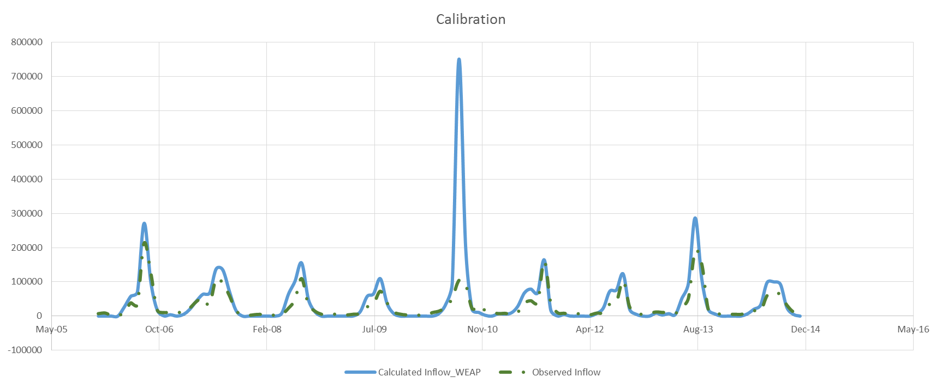
Figure 1: Calibration for simulated and observed values

System Performance

Water System Reliability
Additional supply is a good management strategy in terms of increasing the reliability of water system in Jamshoro city. Figure 2: Demand site reliability for Jamshoro city for different additional supply options shows that under reference scenario (blue dotted line), in which there is neither an increase in the storage capacity nor enough pumping capacity is installed and with population increase as 5%, demand coverage is decreasing with respect to time. Reliability in terms of demand coverage under additional supply options remained higher than the reference scenario. Figure 2 also shows that the demand coverage for all the supply solutions remain same till Nov 2010, and it changed gradually after that.

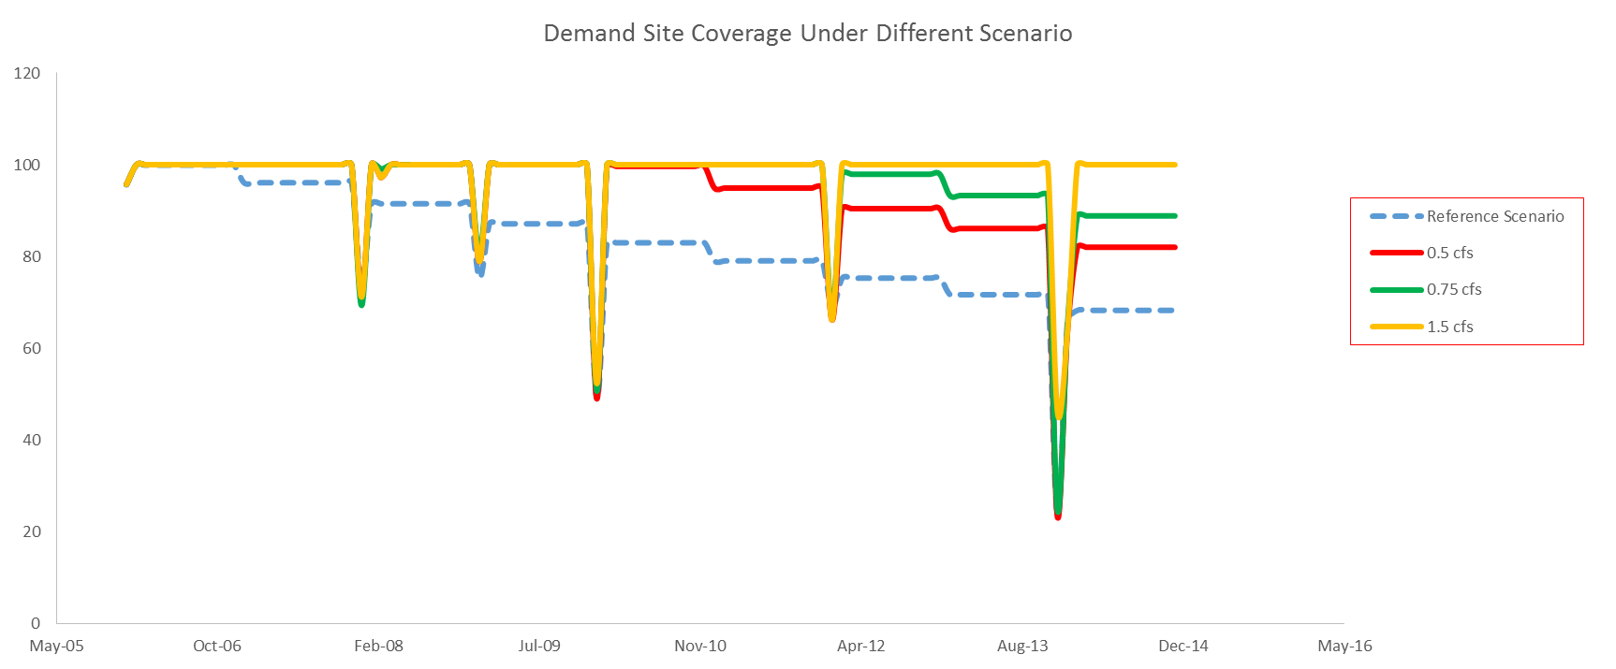
Figure 2: Demand site reliability for Jamshoro city for different additional supply options

Water System Resiliency
The resiliency over the reference scenario (with no additional supply) was observed to be 12 percent. As the Figure 2 shows that the demand coverage is less than 100% throughout the reference period after 2006 which means that the system was unable to bounce back from the failure. Thus it reflects the low resiliency value of the system. The higher the pumping capacity of the additional supply, the higher the resiliency of the water system was observed. The values obtained for the resiliency of the additional supply with the pumping capacity of 0.5 cfs, 0.75 cfs and 1.5 cfs are provided in Table-1.
Water System Vulnerability
The vulnerability over the reference scenario (with no additional supply) was observed to be 98 percent while it decreased with the additional supply. The higher the pumping capacity of the additional supply the lower the vulnerability of the water system was observed. The values obtained for the vulnerability of the additional supply with the pumping capacity of 0.5 cfs, 0.75 cfs and 1.5 cfs are provided in Table-1.
Table 1: Resiliency and Vulnerability for different additional supply options
Scenerios | Resiliency | Vulnerability
Reference | 0.11 | 0.98
With Supply (0.50 cfs) | 0.44 | 0.81
With Supply (0.75 cfs) | 0.67 | 0.47
With Supply (1.5 cfs) | 0.89 | 0.02

Cost Benefit Analysis (CBA)
Figure 3: Average monthly cost for different additional supply options shows the average monthly cost per cubic meter of water. The cost is observed to be increasing for additional supply. The values are higher in winter when there is no supply from KB Feeder canal and additional supply from Kotri requires additional pumping costs from long distance.
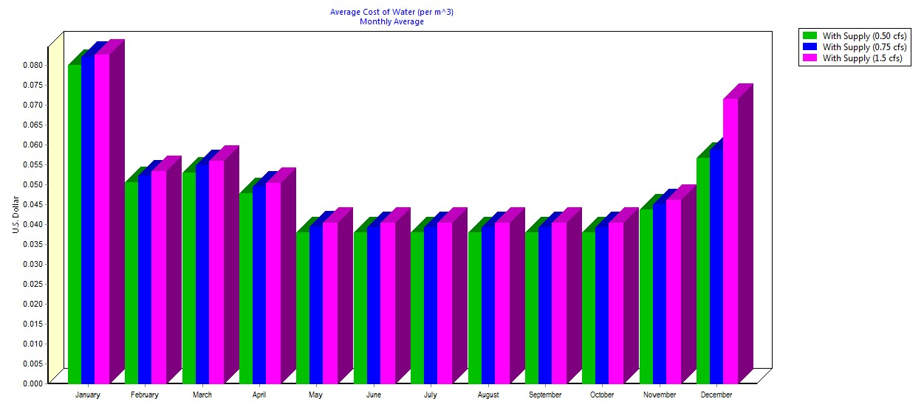
Figure 3: Average monthly cost for different additional supply options
Figure 4: Net benefit for additional supply options below presents the net benefit for additional supply options. The higher the storage and pumping capacity of the additional supply higher the net benefit obtained. However, it also involves higher capital and operating cost. The supply options with less storage and pumping capacity on the other hand involve less capital and operating cost but also lower net benefit.

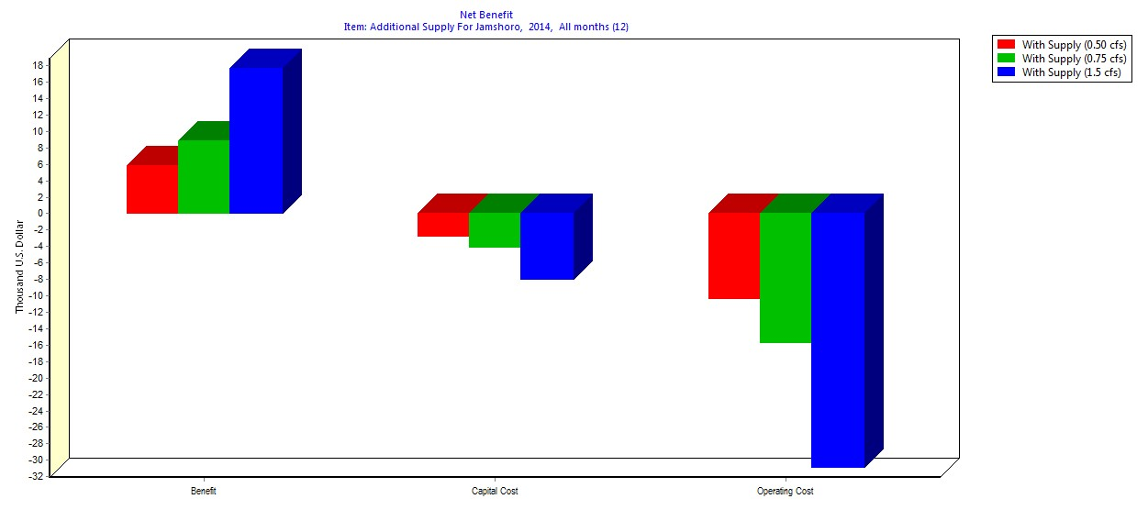
Figure 4: Net benefit for additional supply options

Tradeoffs among quantitative metrics and stakeholder objectives
Depending upon the financial capability of the stakeholder, tradeoffs could be achieved among different quantitative metrics and stakeholder objectives through choosing from different capacity of additional supply. That’s why multiple capacity of additional supply has been simulated (Annexure 3) to address the associated system improvements, benefit and cost to the stakeholder.

Conclusion
System performance metrics, under different scenario, are linked with the cost benefit analysis to facilitate the managers in decision making. The results under reference scenario reflects the present unsatisfactory conditions, while conditions get better under different additional supply scenario. But with additional supply, it can be seen that total capital and operating cost increases. With scenario involving less capital and operating cost, the condition is still better with respect to reference scenario.
References
Archer, David R., Nathan Forsythe, Hayley J. Fowler, and Syed Muhammed Shah. "Sustainability of water resources management in the Indus Basin under changing climatic and socio economic conditions." Hydrology and Earth System Sciences 14, no. 8 (2010): 1669-1680.
Condappa et al. (2009). Assessment and Planning of the water resource of the Indo-Ganges with the Water Evaluation and Planning (WEAP) model: glaciers' contribution, current situation and possible scenarios.
Hashimoto, Tsuyoshi, Jery R. Stedinger, and Daniel P. Loucks. "Reliability, resiliency, and vulnerability criteria for water resource system performance evaluation." Water resources research 18, no. 1 (1982): 14-20.
Laghari, A. N., Davy Vanham, and Wolfgang Rauch. "The Indus basin in the framework of current and future water resources management." Hydrology and Earth System Sciences 16, no. 4 (2012): 1063-1083.
Memon, Mehrunisa, Mohammed Saleh Soomro, Mohammad Saleem Akhtar, and Kazi Suleman Memon. "Drinking water quality assessment in Southern Sindh (Pakistan)." Environmental monitoring and assessment 177, no. 1-4 (2011): 39-50
Sheikh, Munawar A. "Energy and renewable energy scenario of Pakistan."Renewable and Sustainable Energy Reviews 14, no. 1 (2010): 354-363.
Drinking water quality assessment in Southern Sindh (Pakistan). Available from: https://www.researchgate.net/publication/45289231_Drinking_water_quality_assessment_in_Southern_Sindh_Pakistan [accessed May 4, 2016].

Annexures
Annexure 1: WEAP schematics for Sukkur and Kotri Barrage
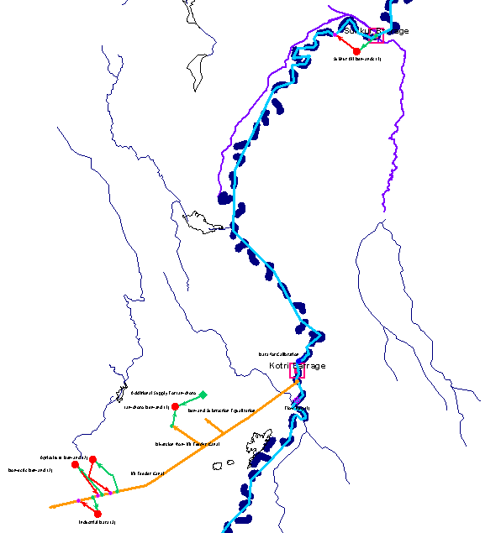

Annexure 2: Methodological Framework
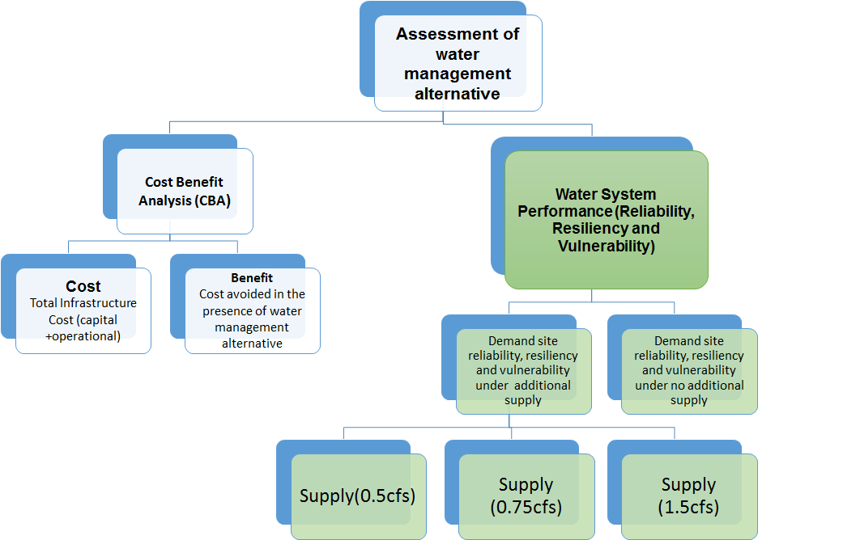

Annexure 3: Cost associated with different storage and pumping requirements
